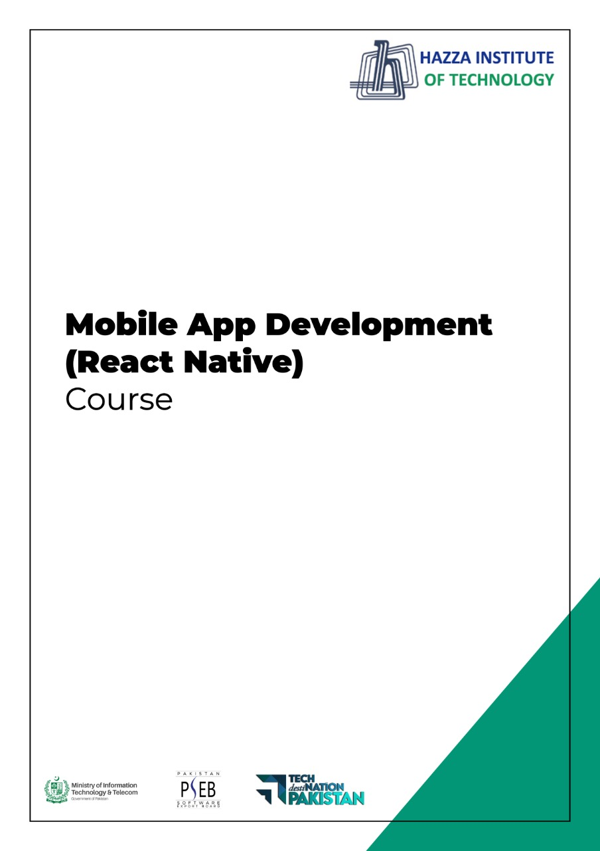
(Flutter)
Flutter Lab 3 (Session 2)

Total Time:
6 hours (2 sessions)

Pre-Lab Activities:
  - Basics of Flutter
  - Familiar with Android Studio and Flutter Application Mode
  - Familiar with Basic Widgets

Learning Outcomes:
- Demonstrate the knowledge of Flutter to design stateful, cross-platform, and interactive user interfaces for mobile applications.
- Demonstrate the basic widgets desgin

Student Activities:
- Student create a new flutter project in Android Studio and Write the code for some basic Widgets.

Lab Tasks 1:
- Create a contact-card app that shows your contact details as given in following figure. The components and requirements of this app are given below.
  - Include safe area
  - Grey background
  - Contain a circular avatar with an image, and 50 radius.
  - Your name with following style guidelines
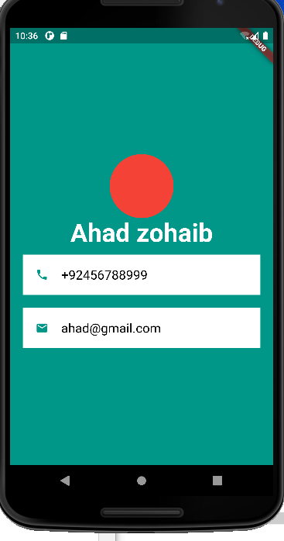
    - Font ZenKurenaido (custom Google font)
    - Bold
    - White Color
    - Font size 30
  - Your Designation with following style guidelines
    - Font Lato (custom Google font)
    - Bold
    - White Color
    - Font size 20
    - Letter spacing 3
  - Phone icon and contact number with green color, white background, padding, and margin
  - Email icon and email with green color, white background, padding, and margin

Lab Solutions:

LAB 3.1 : Practicing Layout Widgets.

CODE:
import 'dart:ui';

import 'package:flutter/cupertino.dart';
import 'package:flutter/material.dart';

void main() {
runApp(const MyApp());
}

class MyApp extends StatelessWidget {
const MyApp({Key? key}) : super(key: key);

// This widget is the root of your application.
@override
Widget build(BuildContext context) {
return MaterialApp(
title: 'PortFolew',
home: Scaffold(
backgroundColor: Colors.teal,
body: SafeArea(
child: Column(
mainAxisAlignment: MainAxisAlignment.center,
children: [
CircleAvatar(
backgroundColor: Colors.amber,
radius: 70,
backgroundImage: AssetImage('images/myimage.jpg'),

),
Text('Muhammad bin Abdul Ghaffar',style: TextStyle(
fontFamily: 'Schyler',
fontSize: 40,
fontWeight: FontWeight.bold,
color: Colors.white,
),),
Text('Class Sixth', style: TextStyle(
color: Colors.amber,
fontSize: 20, letterSpacing: 2.5, fontWeight: FontWeight.bold),),
SizedBox(width: 150, height: 100,
child: Divider(color: Colors.white70),),
// Container with ListTile without rounded corner
Text('Container with List Tile without rounded corner'),
Container(
color: Colors.white,
margin: EdgeInsets.symmetric(vertical: 10, horizontal: 20),
child: ListTile(
title: Text('03314741950', style: TextStyle(color: Colors.teal, fontWeight: FontWeight.bold, fontSize: 18,), ),
leading: Icon(Icons.phone, color: Colors.teal,),
),
),

// card with ListTile with round corner
Text('Card with List Tile with round corner'),
Card(
color: Colors.white,
margin: EdgeInsets.symmetric(vertical: 10, horizontal: 20),
child: ListTile(
title: Text('abc@google.com', style: TextStyle(color: Colors.teal, fontWeight: FontWeight.bold, fontSize: 18),),
leading: Icon(Icons.email, color: Colors.teal,),
)),

// Container with Row
Text('Container with Row'),
Container(
padding: EdgeInsets.all(10),
color: Colors.white,
margin: EdgeInsets.symmetric(vertical: 10, horizontal: 20),
child: Row(
mainAxisAlignment: MainAxisAlignment.center,
children: [
Icon(Icons.phone, color: Colors.teal,),
SizedBox(width: 30,),
Text('03314741950', style: TextStyle(color: Colors.teal, fontWeight: FontWeight.bold, fontSize: 18,), )
],
),
),
// Card with Padding & Row
Text('Card with Padding & Row'),
Card(
margin: EdgeInsets.symmetric(vertical: 10, horizontal: 20),
color: Colors.white,
elevation: 15.0,
child: Padding(
padding: EdgeInsets.all(10),
child: Row(
mainAxisAlignment: MainAxisAlignment.center,
children: [
Icon(Icons.email, color: Colors.teal,),
SizedBox(width: 30,),
Text('abc@google.com', style: TextStyle(color: Colors.teal, fontWeight: FontWeight.bold, fontSize: 18),),
],
),
),
),
],
),
),
)
);
}
}

